**Phase I Clinical Trials in Cancer Treatment**

**Megan Wang**

Bellaire High School

**Supervisor: Suyu Liu, PhD**

Department of Biostatistics

The University of Texas MD Anderson Cancer Center

**Statistical Analyst Summer Internship (June - August 2024)**

**Introduction**

Phase I clinical trials are essential in developing anticancer drugs and are the first step in testing new drugs. Phase I clinical trials focus on assessing a new drug's safety, tolerability, and pharmacokinetics/pharmacodynamics and determining the maximum tolerated dose (MTD) and recommended dose for Phase II trials. The primary goal of Phase I clinical trials is to determine the MTD, the highest dose patients can receive without unethical harmful side effects. Phase I clinical trials may have two parts: (1) dose-finding part; and (2) dose expansion part. The goal of the dose-finding part is to find the MTD by sequentially testing the toxicity of the study drug from low dose to high dose level. The goal of the dose expansion part is to continue treating patients at the MTD determined in the dose-finding part to further confirm the safety of the study drug as well as assess the preliminary efficacy profile. Statistical methods/designs are applied to the dose-finding process to efficiently explore the dose space and select the MTD. Methods can include 3+3, BOIN (Bayesian Optimal Interval Design), mTPI (Modified Toxicity Probability Interval), CRM (Continual Reassessment Method), and other designs.

The objective of this project is:

1. Learn the basic concepts of phase I clinical trial designs
2. Perform a literature review of the published phase I clinical trials
3. Summarize the common phase I clinical trial parameters
4. Conduct simulation studies of the novel design used at MD Anderson Cancer Center, the BOIN design (Ongoing)

* **Two Stages of Phase I Clinical Trial**

The first stage of a phase I clinical trial is dose escalation or dose finding. During dose escalation, patients are enrolled into different dose levels. Depending on how many patients experience dose-limiting toxicity (DLT) in a cohort, the study will either test the same dose level again, drop down a dose level, or escalate to a higher dose level. This dose escalation and de-escalation is used to determine the MTD. Dose escalation tends to use fewer patients and smaller cohort sizes to be ethical. In dose levels with a greater number of DLTs or severe side effects, small cohort sizes will result in fewer patients harmed, maintaining an ethical clinical trial. Cohort sizes of between 1 and 3 are typically used in phase I dose-escalation trials.

The second stage of a phase I clinical trial is dose expansion. In dose expansion, the MTD will be further evaluated and tested for safety as well as preliminary efficacy. After the MTD is determined by dose escalation, the drug dose will be given to additional patients to better understand its effects. Expansion cohorts can be used to explore specific patient populations, such as those with particular biomarkers or genetic profiles, providing more detailed data on the drug's effects.

* **Phase I Clinical Trials**

The goal of phase I clinical trials is to determine the safety profile and select the MTD of the study drug. The primary endpoint is the toxicity. In a phase I clinical trial, we need to define the following parameters:

1. DLT including the toxicity events as well as the assessment time window
2. Target or acceptable toxicity rate and the definition of MTD
3. Patient population
4. Dose levels including the starting dose of the study drug
5. Cohort size in the dose-finding
6. Total sample size

**Methods**

In order to understand the phase I clinical trials being conducted and how the design parameters are being used. We performed a literature review of the published phase I trials on ClinicalTrials.gov by using the following criteria:

* Period of 1/1/2014 ~ 12/31/2023
* Completed studies
* Protocol available
* Adult cancer patients (18 - 64 years)
* Patients of all sex
* Phase 1 studies
* Results available

We compiled a list of 127 Phase I clinical trials from [ClinicalTrials.gov](http://clinicaltrials.gov) with the criteria above. Among them, only 54 clinical trials were specified using a design. Table 1 below summarizes the designs being used.

**Table 1. Summary of the Designs Based on 54 Studies**

|  |  |  |  |  |  |  |
| --- | --- | --- | --- | --- | --- | --- |
| Design Name | 3+3 | BOIN | mTPI | CRM | Other | **Total** |
| N (%) | 31 (57.4%) | 1 (1.9%) | 2 (3.7%) | 1 (1.9%) | 19 (35.2%) | **54 (100%)** |

As seen in the table above, the 3+3 design is the most commonly used design. Though straightforward and widely used, the 3+3 design is often criticized for its poor performance in terms of low selection probability of the correct MTD and more patients being assigned to overly toxic doses [1-4]. Despite the development of many clinical trial designs that prove to be more efficient and accurate, the primary reason for the consistent popularity of the 3+3 design is its simplicity and it is well understood by clinicians. The decision rule for drug dose escalation and de-escalation in the 3+3 design is determined before the trial, and it is relatively easy to understand and utilize as it is a rule-based design [1-4].

* **BOIN vs. 3+3**

The 3+3 design starts at the lowest dose level and treats 3 patients at a time. Examining how many patients experience a DLT (dose limiting toxicity) in each dose level; if 0 of 3 patients experience a DLT, then the dose will be escalated to the next dose level; if 1 of 3 patients experience a DLT, then the study will enroll 3 more patients to the same dose level again; if 2 or 3 of 3 patients experience a DLT, then the dose escalation will stop and the MTD is determined to be the previous dose level. The 3+3 dose escalation/de-escalation algorithms are shown in Figure 1 [9].

**Figure 1. 3+3 Design Flowchart**

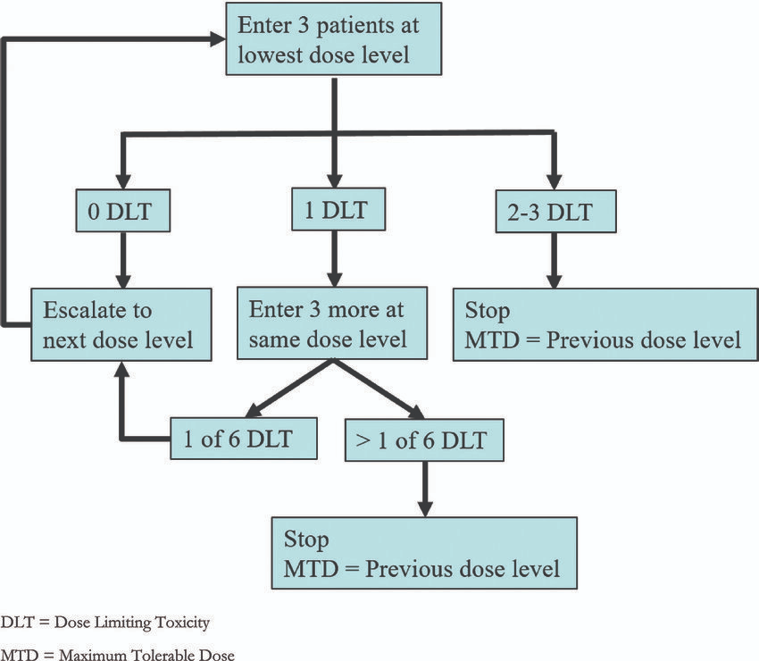

**Figure 2. BOIN Design Flowchart**

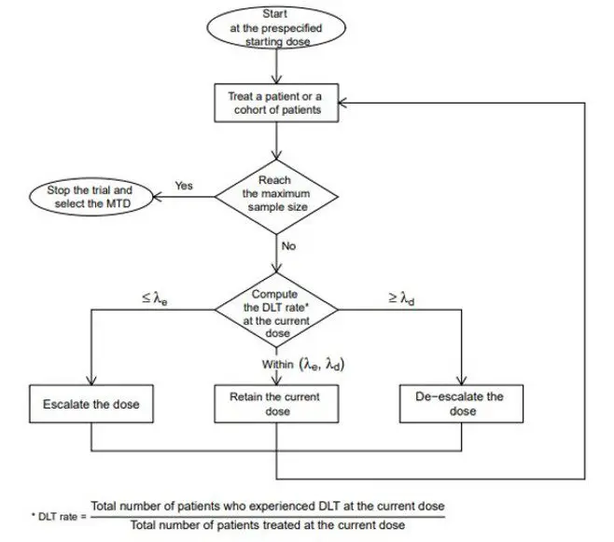

Despite being less commonly used than the 3+3 design among 127 phase I cancer clinical trials from 2014 to 2023, the novel rule-based design, BOIN design has been well accepted and became the most commonly used design at MD Anderson Cancer Center. Figure 2 shows the dosing algorithm of the basic BOIN design, an interval-based, model-assisted design [11]. The BOIN design allows for more flexible dose adjustments since it is built upon a Bayesian probability model applicable to any acceptable toxicity probability. In contrast, the 3+3 design uses a rule-based method that follows a rigid algorithm for dose escalation and de-escalation, making the design less adaptable to cohort sizes not being 3. Additionally, the BOIN design can eliminate overly toxic doses, and can be applied to any cohort size. Therefore, the BOIN design is more efficient, accurate, and safe than the traditional 3+3 design. Figure 3 shows a comparison between BOIN and 3+3 design dose escalation rules [7].

**Figure 3. BOIN vs 3+3 Design**

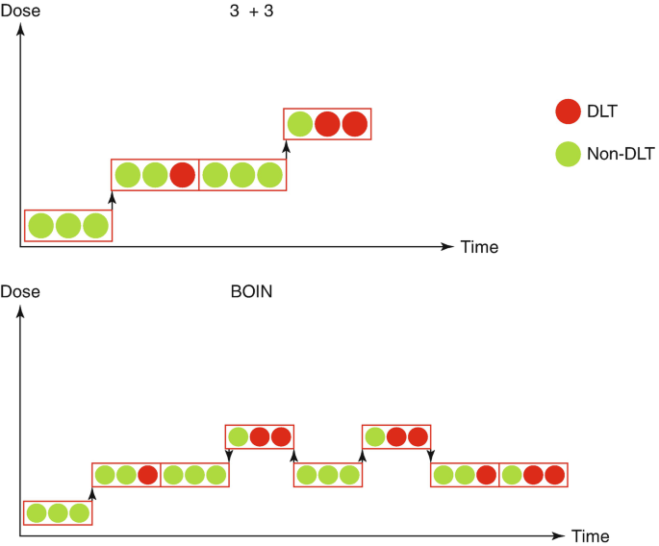

* **BOIN vs. CRM**

CRM and BOIN both are statistically efficient and more accurate in determining MTD than the 3+3 design. However, BOIN is easier to understand, easier to implement, and it is user-friendly to clinicians with limited statistical expertise as BOIN design can explicitly give the dose escalation/de-escalation boundary table. CRM heavily relies on the Bayesian model, rendering it less practical for clinicians who do not have extensive training or understanding of the Bayesian methods. BOIN offers a balance of efficiency, safety, and ease of use, making it easy to use while still providing improvements in accuracy and efficiency over traditional methods like the 3+3 design.

* **BOIN vs. mTPI**

mTPI is also considered a more accurate and efficient design compared to the 3+3 design. mTPI and BOIN are both model-assisted designs and use Bayesian statistical methods to guide dose escalation. Despite their similarities, BOIN is more likely to determine the MTD correctly and has a significantly lower risk of overdosing patients than mTPI. Figure 4 shows the mTPI dose escalation/de-escalation rule [10].

**Figure 4. mTPI Decision Table**

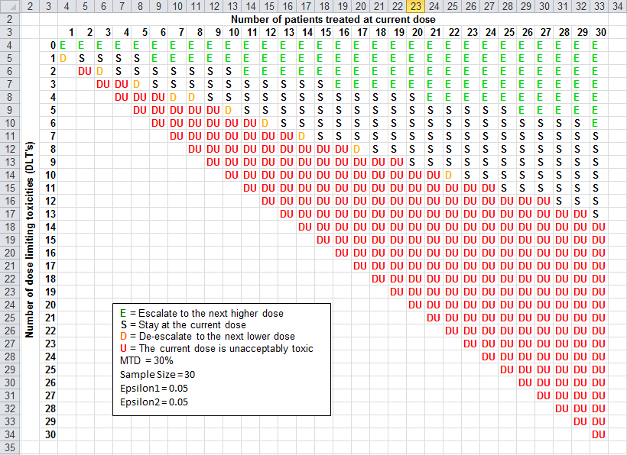

**Results**

After reviewing 127 phase I clinical trial studies during 2014-2023, I have collected data regarding single or combination drugs, dose-finding, dose expansion, design, dose levels, sample sizes, toxicity-stopping rules, and phase II. The data collected are shown in Table 2 below.

|  |  |  |
| --- | --- | --- |
| **Table 2. Summary Results for 127 Researched Phase I Clinical Trials** | | |
| **Parameters** | **Levels** | **N (%)** |
| **Single or Combination Drug** |  |  |
|  | Single | 41 (32.3%) |
|  | Combination | 67 (52.8%) |
|  | Both | 10 (7.9%) |
|  | None | 5 (3.9%) |
|  | NA | 4 (3.1%) |
|  |  |  |
| **Dose Escalation** |  |  |
|  | Yes | 79 (62.2%) |
|  | No | 48 (37.8%) |
|  |  |  |
| **Design** |  |  |
|  | 3+3 | 31 (57.4%) |
|  | BOIN | 1 (1.8%) |
|  | mTPI | 2 (3.7%) |
|  | CRM | 1 (1.8%) |
|  | Other | 19 (35.2%) |
|  | NA | 73 |
|  |  |  |
| **Other Design** |  |  |
|  | Parallel | 6 (30%) |
|  | Sequential | 12 (60%) |
|  | EWOK | 1 (5%) |
|  | Rolling 6 | 1 (5%) |
|  |  |  |
| **More Than One Drug** |  |  |
|  | Yes | 28 (22.0%) |
|  | No | 99 (78.0%) |
|  |  |  |
| **Sample Size of Dose Escalation** |  |  |
|  | n | 72 |
|  | mean | 36.4 |
|  | STD | 39.4 |
|  | Median | 21.5 |
|  | Range (Min-Max) | 1 to 213 |
|  |  |  |
| **No. of dose level** |  |  |
|  | n | 67 |
|  | mean | 3.66 |
|  | STD | 1.35 |
|  | Median | 3 |
|  | Range (Min-Max) | 1 to 10 |
|  |  |  |
| **Dose Expansion** |  |  |
|  | Yes | 61 (48.0%) |
|  | No | 66 (52%) |
|  |  |  |
| **Sample Size Dose Expansion** |  |  |
|  | n | 56 |
|  | mean | 40 |
|  | STD | 42.1 |
|  | Median | 23.5 |
|  | Range (Min-Max) | 6 to 213 |
|  |  |  |
| **Toxicity Stopping Rule for Dose Expansion** |  |  |
|  | Yes | 15 (11.8%) |
|  | No | 112 (88.2%) |
|  |  |  |
| **Phase II** |  |  |
|  | Yes | 50 (39.3%) |
|  | No | 77 (60.7%) |
|  |  |  |
| **Sample Size Phase II** |  |  |
|  | n | 45 |
|  | mean | 41.96 |
|  | STD | 45.27 |
|  | Median | 28 |
|  | Range (Min-Max) | 6 to 213 |

**Figure 5. Design Methods and Important Parameters of Phase I Clinical Trial**

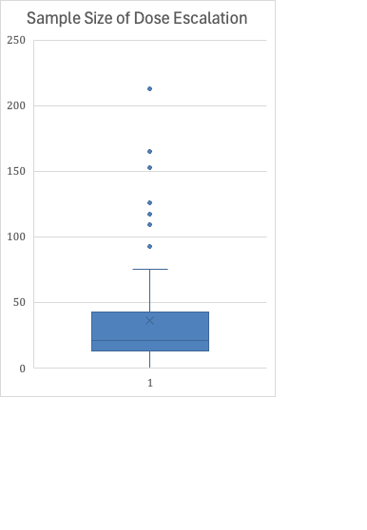 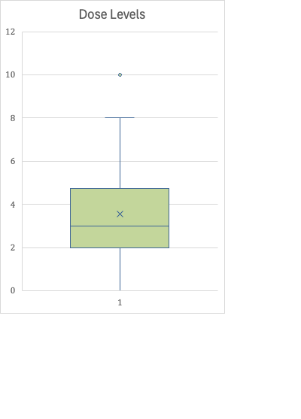

The majority of studies involved a combination drug (52.8%) while 32.3% of studies used a single drug and 7.9% of studies involved both combination and single drugs. Most studies had a dose escalation stage (62.2%) which most commonly used a 3+3 dose escalation design (57.4%). Other designs used in dose escalation include sequential assignment (60.0%), parallel assignment (30.0%), EWOK (5.0%), and Rolling 6 design (5%). Most dose escalation studies did not seek to find the MTD for more than one drug (78.0%). In dose escalation studies, the mean number of dose levels was 3.66 dose levels. Even though phase I clinical trials often include both dose escalation and dose expansion stages, most studies did not include a dose expansion stage (52%) and only 11.8% of total studies had toxicity-stopping rules for dose expansion. These studies did not specify or differentiate the sample size of dose escalation from that of dose expansion, only providing the total enrollment of the study. With limited information, the mean sample size of dose escalation cohorts is 36.4 patients and the mean sample size of dose expansion cohorts is 40 patients. Most studies did not immediately follow up with a phase II trial (60.7%) in the phase I protocols. Among 45 phase II trials, the mean sample size was 41.96.

**Conclusions**

In the past two months of this summer internship, I have learned the importance of phase I clinical trials and how statistics are vital in ensuring patient safety when determining the MTD. Despite being dominated by the 3+3 design, the BOIN design stands as the most efficient and accurate dose escalation method because of its use of the Bayesian probability model which considers all observed data and previous knowledge. Additionally, the BOIN design is versatile and user-friendly, making it superior to other methods.

**References**

1. Liu S. and Yuan, Y. (2015). Bayesian optimal interval designs for phase I clinical trials, Journal of the Royal Statistical Society: Series C , 64, 507-523.
2. Iasonos A, Wilton AS, Riedel ER, Seshan VE, Spriggs DR. A comprehensive comparison of the continual reassessment method to the standard 3 + 3 dose escalation scheme in Phase I dose-finding studies. Clin Trials. 2008;5(5):465-77. doi: 10.1177/1740774508096474. PMID: 18827039; PMCID: PMC2637378.
3. Yuan Y, Hess KR, Hilsenbeck SG, Gilbert MR. Bayesian Optimal Interval Design: A Simple and Well-Performing Design for Phase I Oncology Trials. Clin Cancer Res. 2016 Sep 1;22(17):4291-301. doi: 10.1158/1078-0432.CCR-16-0592. Epub 2016 Jul 12. PMID: 27407096; PMCID: PMC5047439.
4. Zhou H, Yuan Y, Nie L. Accuracy, Safety, and Reliability of Novel Phase I Trial Designs. Clin Cancer Res. 2018 Sep 15;24(18):4357-4364. doi: 10.1158/1078-0432.CCR-18-0168. Epub 2018 Apr 16. PMID: 29661774.
5. Cabrera, J. R., Taylor, J. W., & Molinaro, A. M. (2016). Phase I cancer clinical trials†. Neuro-Oncology Practice, 4(1), 67–72.
6. Wheeler, G.M., Mander, A.P., Bedding, A. et al. How to design a dose-finding study using the continual reassessment method. BMC Med Res Methodol 19, 18 (2019).
7. Hess, K.R., Fellman, B.M. (2020). Examining Performance of Phase I Designs: 3+3 Versus Bayesian Optimal Interval (BOIN). In: Yap, T.A., Rodon, J., Hong, D.S. (eds) Phase I Oncology Drug Development.
8. Ji Y, Wang SJ. Modified toxicity probability interval design: a safer and more reliable method than the 3 + 3 design for practical phase I trials. J Clin Oncol. 2013 May 10;31(14):1785-91. doi: 10.1200/JCO.2012.45.7903. Epub 2013 Apr 8. PMID: 23569307; PMCID: PMC3641699.
9. Kim, Guowei & Tan, Hon & Chen, Elya & Teo, Siok & Jang, Clarisse & Ho, Jingshan & Ang, Yvonne & Ngoi, Natalie & Chee, Cheng & Lieske, Bettina & Shabbir, Asim & Wang, Lingzhi & So, Jimmy & Yong, Wei. (2018). Study protocol: phase 1 dose escalating study of Pressurized Intra-Peritoneal Aerosol Chemotherapy (PIPAC) with oxaliplatin in peritoneal metastasis. Pleura and Peritoneum. 3. 10.1515/pp-2018-0118.
10. <https://biostatistics.mdanderson.org/SoftwareDownload/SingleSoftware/Index/72>
11. <https://www.precisionformedicine.com/blog/phase-i-clinical-trial-designs-bayesian-optimal-interval-design-boin/>
12. Le Tourneau C, Lee JJ, Siu LL. Dose escalation methods in phase I cancer clinical trials. J Natl Cancer Inst. 2009 May 20;101(10):708-20. doi: 10.1093/jnci/djp079. Epub 2009 May 12. PMID: 19436029; PMCID: PMC2684552.

**Appendix I**

**Glossary of Terms**

|  |  |
| --- | --- |
| **Term** | **Definition** |
| Cohort | Group of patients treated at a dose level |
| Dose-limiting toxicity (DLT) | Toxic effects of drugs that are considered unacceptable (often because of their severity and irreversibility) will limit further dose escalation |
| Maximum-tolerated dose (MTD) | The highest dose level that does not exceed the target toxicity |
| Dose Level | The starting dose is usually a fraction of the dose found to be safe in preclinical studies; dose levels are increased according to predefined escalation schemes until the MTD is reached |
| Recommended phase II dose | The drug dose found in phase 1 and identified for continued study in future clinical trials; cannot exceed MTD |
| Single or Combination | Only one type of drug is administered (single); a combination of multiple drugs are being administered at once (combination) |
| Dose escalation | Patients are enrolled into different dose levels to find the MTD and/or recommended phase II dose; also known as dose-finding |
| Dose expansion | Following dose escalation; adds additional patients to further evaluate the efficacy, safety, toxicity, and pharmacokinetics of a drug dose before moving into phase II |
| Pharmacokinetics (PK) | How the body affects the drug; includes the absorption, distribution, and excretion of a drug |
| Pharmacodynamics (PD) | How the drug affects the body |
| Phase II | Following phase I; evaluate the efficacy and toxicity of the drug; typically has a larger sample size compared to dose expansion |
| Toxicity stopping rules | Using the Bayesian probability model to identify stopping boundaries and ensure patient’s safety |